UNIVERSAL AIR CONDITIONER REMOTE
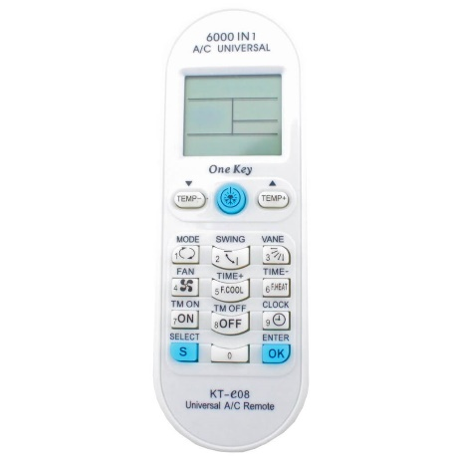

Search for your Brand on the supplied code list to locate the associated Code Range for your air conditioner unit.

Aim the Remote at the Air-Conditioning Unit

Press the “S” Select button and hold for approximately 5 Seconds. (Code Numbers will flash in the bottom right hand corner of the digital screen.

Press the “TEMP” arrow buttons either Up or Down to find your Code Range.

For Fast Search – Hold down the Up or Down Arrows

For Slower Search – Press Up and Down Arrows Slowly.

Once in your Code Range –use the slower search to find the right number for your unit type. Once the remote synchronizes with the Air Conditioning unit – it will beep and the Air Conditioner unit will turn on. (this process may take up to 10-15 mins depending on Brand/Code Number)

Once Beeps, press “OK” –

Note: If you were a little too quick and missed the beeping sound – just press the “TEMP” arrow button up or down (opposite to what you were doing) to find the required code number with the associated beep.

