 | Compatibility List:  ACDC Red, Heavy Metal, Clear Case, Green  ATA PTX4  Avanti PTX4, TX4, Style, Euro  Boss HT3 Red Light  BFT Mitto 2, Mitto 4  Beninca TWV2 TWV4  Cenution TX4, Style, New Style  DEA MIO TR2, MIO TR4, MIO TD2, MIO TD4  ECA TX4  ET Doors Red  FAAC XT4433RC  Fadini Astro 43-2  Gibidi Domino Series  Herculift  Key Sub44  Letro AR1  MHouse GTX4, TX4  Napoleon Red  Smart Duo, Quattro  Steel-Line ZT-07, HT3 Red Light  Superlift TX4, Style, Euro |  |  | 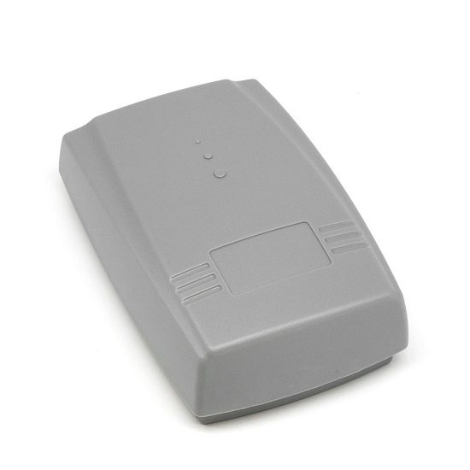  Standard Specs:  Frequency: 433.92MHz  Coding: Fixed & Rolling Code  Body Type: Receiver  Channels: 2  Button Colour: N/A  Colour: Grey  Remote Size: 90x60x20mm  Range: >40 Meters
HOW TO CODE YOUR REMOTE  Code to CHANNEL 1  Step 1:  Press the CH1 LEARN button ONCE on the receiver and then release.  The LED will stay solid.  Step 2: Press the button required on the remote.  LED will flash 5 times and turn off.  Code to CHANNEL 2  Step 1:  Press the CH2 LEARN button ONCE on the receiver and then release.  The LED will stay solid.  Step 2: Press the button required on the remote.  LED will flash 5 times and turn off. |  |  | HOW TO DELETE ALL REMOTES  Step 1: Hold LEARN button on either channel down.  LED will come on for approximately 5 seconds and then go out.  You have now cleared all remotes from the receiver for that channel. Repeat on other channel if required.
 | HOW TO WIRE A 3-WIRE SYSTEM  1 - SWITCH = CH1 N/O Terminal  2 - 12/24v POSITIVE = POS Terminal  3 - NEGATIVE = GND Terminal  Link GND & CH1 COM Terminals | 