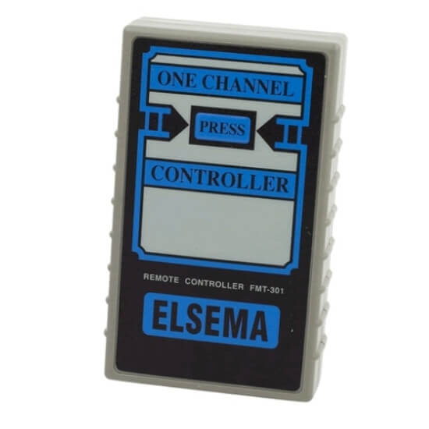
ELSEMA FMT 301 -12 SWITCH REMOTE
CODING INSTRUCTIONS

CODING THE REMOTE – ELSEMA FMT 301
Copy the coding sequence in the receiver or match the 12 x DIP switches from a working ELSEMA remote
CODING THE RECEIVER – ELSEMA FMT 301
Copy the coding sequence in the receiver or match the 12 x DIP switches from a working ELSEMA remote – Reverse code if receiver is ATA.

ATA, MAGIC BUTTON & FIRMADOOR TXA1 TO ELSEMA CONVERSION
SINGLE BUTTON remotes can work together if you reverse code in the ELSEMA remote. If TXA1 switch #1 is ON then the ELSEMA switch # 12 is ON, 2 = 11, 3 = 10, 4 = 9, Etc.
EXAMPLE TXA1 CODE SET 4, 6, 7 & 8 ON = ELSEMA CODE SET 5, 6, 7 & 9 ON
PLEASE NOTE: - ELSEMA 2 & 4 button remotes cannot work together with ATA, FIRMADOOR & MAGIC BUTTON 2 & 4 button remotes. To move forward with your openers into the future, you should start again with ELSEMA and recode your receivers to suit.

TRANSFERING CODE FROM A 10 SWITCH FMT 101 TO A 12 SWITCH FMT & KEY 301
To program a FMT & KEY301 remote, you just need to duplicate the coding of your old remote (back inside the remote) to the new remote, and make sure the coding of old remote is as same as that of new remote. Note: One thing need to be paid attention, since your old remote only has 10 dip switches; the new one has 12, so set the 11 and 12 switches of new remote in the position “on”.

